How to upgrade the firmware on Alcor Access D786M

Remove the tablet from your computer (if it is connected).
Download and unpack the driver files which are required for the upgrade process (Alcor_Access_D786M_drivers.rar)
Open Driver_Auto_Installer_v1.1236.00 folder
Double click on Install.bat file to start the driver installation process.
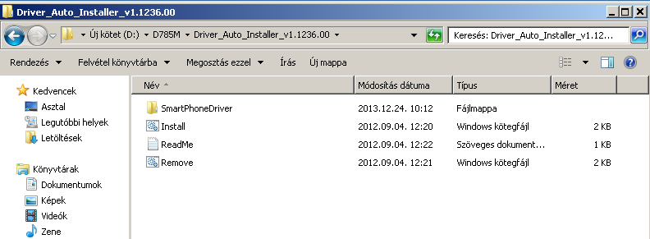
Select „I will install the driver” option in the security pop-up.
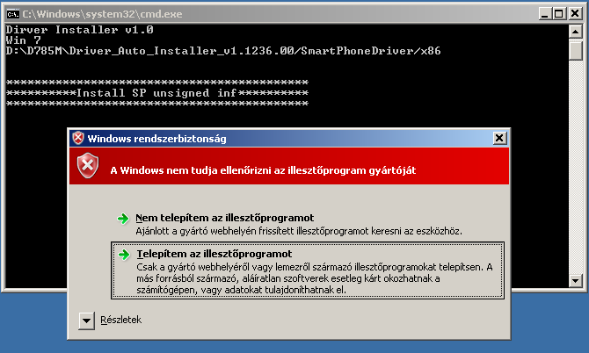

You need to repeat this confirmation four times during the driver installation process.
Press any key to close the command window after driver installation was successful.
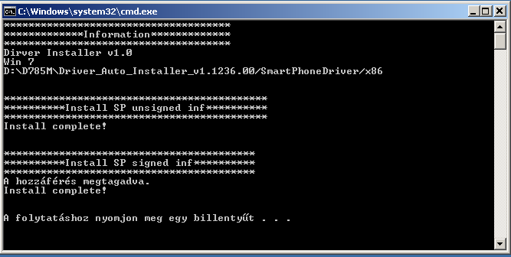

Upgrade process:
Unpack the SP_Flash_Tool_exe_v3.1316.0.150.zip archive and the firmware file.
Start 'Flash_tool' application.
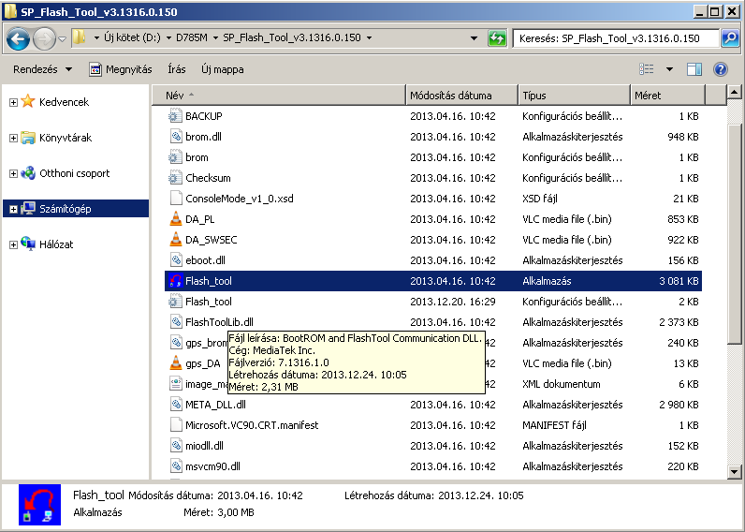
Click 'Scatter-loading'
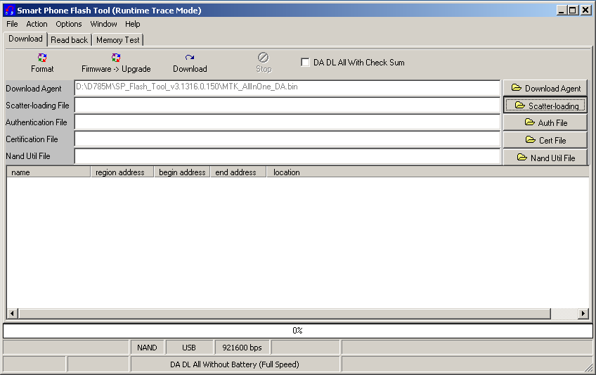

Browse the folder where you have unpacked the firmware to, and select MT6577_Android _scatter_emmc file, then click on the 'Open' button.

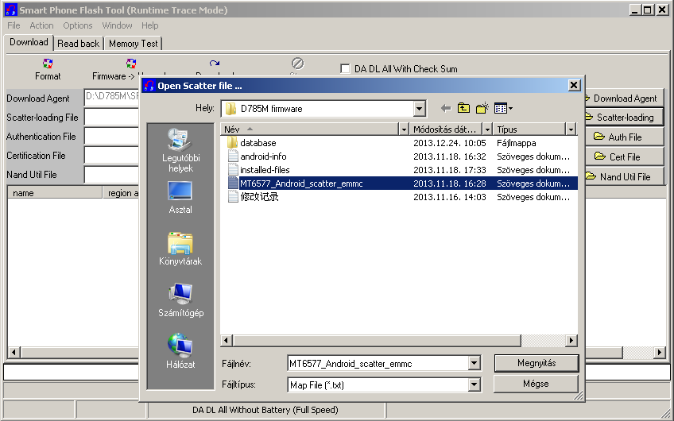
Click on the 'Firmware Upgrade' button or press F8 key.
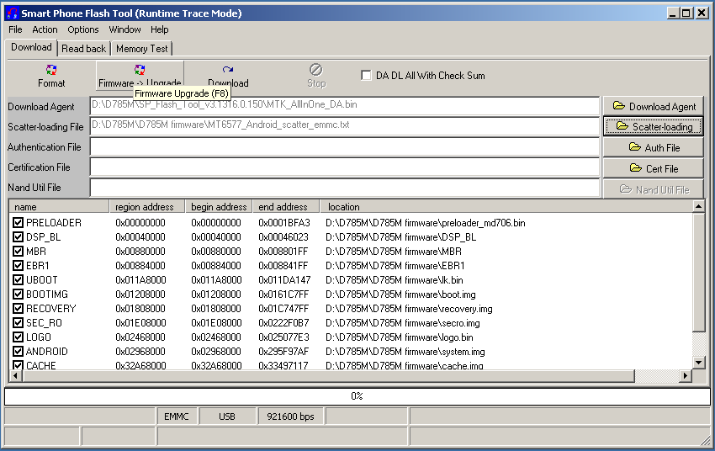

Power off your tablet, then connect it to your computer while you keep pressing VOL-.
The computer will detect the tablet in recovery mode and firmware upgrade process will start.
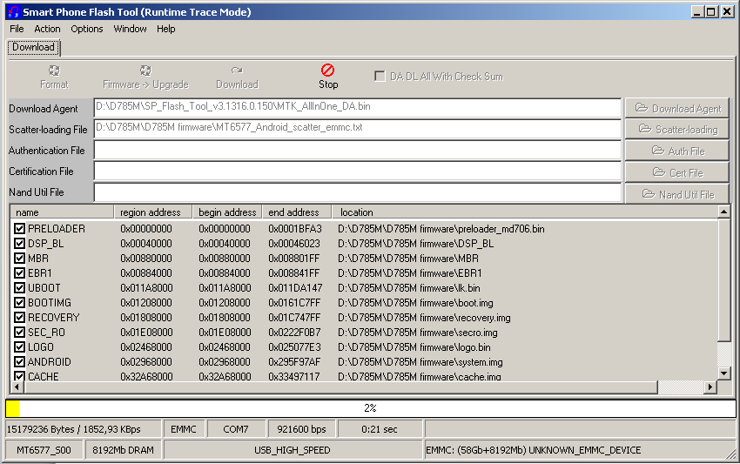
Successful firmware upgrade is shown by a small window with a green circle in it (see image below)
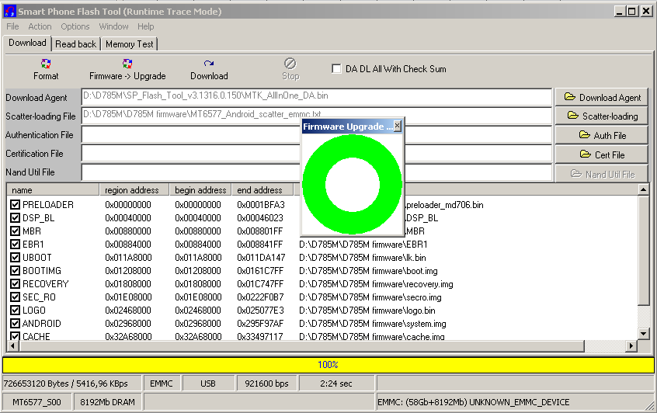
Remove your tablet from the computer and restart it. The first start up process would take longer than usual.

